# Motion-Sensing Doorbell

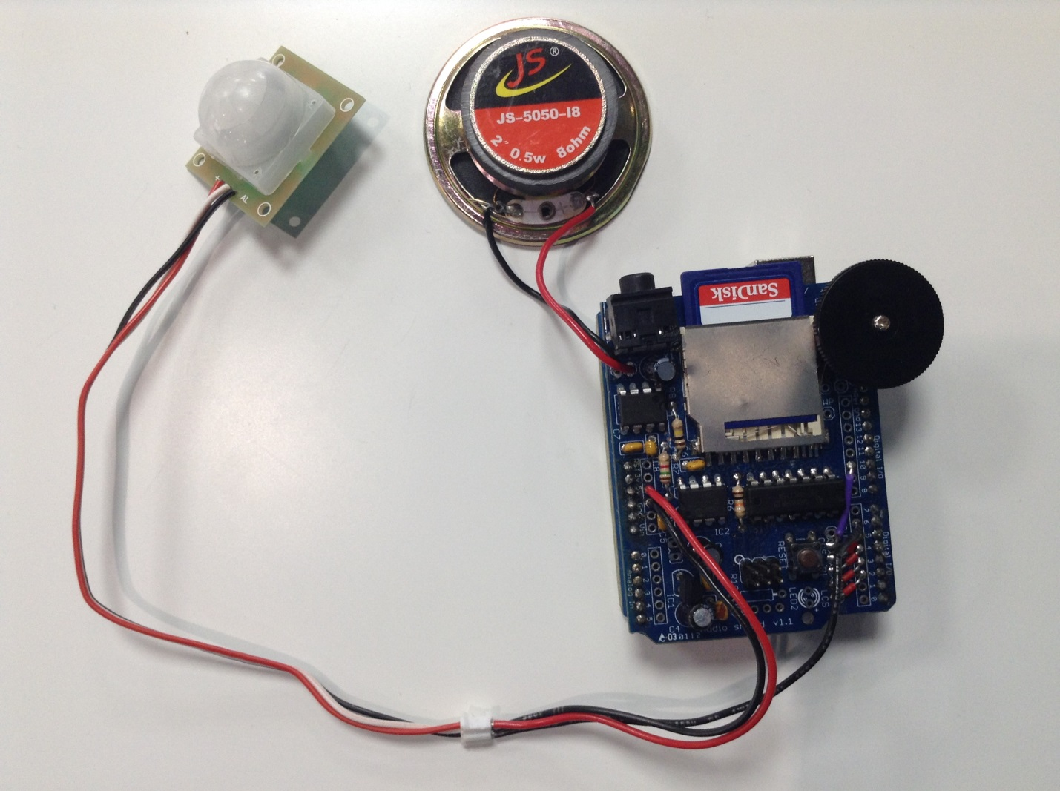

4

3

2

## Main Components/Boards

|  |  |
| --- | --- |
|  | [Arduino Uno](https://www.arduino.cc/en/Main/ArduinoBoardUno) |
|  | [Adafruit Wave Shield for Arduino Kit - v1.1](https://www.adafruit.com/product/94) |
|  | [0.5W 8Ohm Speaker](https://www.sparkfun.com/products/9151) |
|  | [PIR Motion Sensor (JST)](https://www.sparkfun.com/products/13285) |

## Software Required

|  |  |
| --- | --- |
|  | [Arduino IDE (latest)](https://www.arduino.cc/en/Main/Software) |

You can find more information including the **libraries** and **tutorials** by clicking on the links above.

## Functions

### Arduino Uno

This is the development board. It’s the main board interfacing with all other components/boards. I think of it as the “brain” of the system. Once all the setup work such as assembly, wiring, library installations, programming Arduino is done, Arduino and other components/boards can start communicating with each other.

### Adafruit Wave Shield for Arduino Kit - V1.1

This shield interacts with Arduino and plays .wav sound files through the speaker or headphone (optional) connected to it. It can store multiple sound files in the SD card.

### PIR Motion Sensor (JST)

This motion sensor triggers a low-logic level signal to Arduino when it senses motion in its surrounding. When there’s no motion, the signal is always pulled high.